Tab 1

Studenthub Media
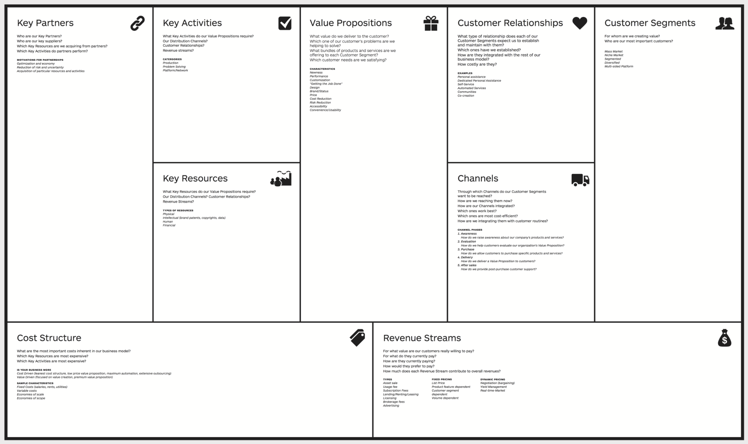
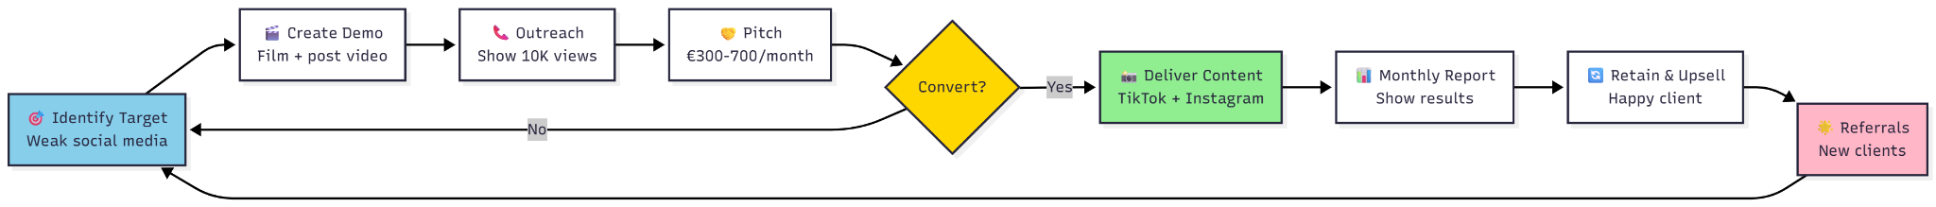

Key Partners:
Small/starting businesses in Groningen

Key Activities:
Social Media content and social media exposure

Value Propositions:
Lead generation, brand awareness

Key Resources:
Audio equipment, video equipment, lighting equipment, premium editing software.

Customer relationships:
Personal assistance.

Channels:
Instagram, LinkedIn, Facebook, TikTok.

Customer segments:
Focus on smaller businesses in a lot of different markets (both b2b and b2c). Segmented market.

Cost structure:
Salary, equipment costs, advertising expenditures.

Revenue streams:
Monthly customer fees

Roles:

CEO: Stijn
Roles: Contact with Smith, delegates tasks, and supervises

External relation: Ilan
Connection/intake with companies, look for customers, research companies.

Creative director: ioana
Marketing of our own company: social media/flyers/events. Instagram/ Tiktok page for our company

Content creation + research: Rusne
Make content, shoot videos/script/edit/

Internal affairs - Julia
Managing the companies finances, backoffice, employee relations

Tab 2
Hi ??,
I hope you're doing well. My name is Ilan, and I’m reaching out on behalf of ??, a fictional social media marketing bureau for a school project. We would like to create some content featuring your store, and we wanted to ask if we have permission to take photos and videos inside your location.
The photos would be used solely for social media purposes and can help highlight your store in a positive way. If you have any guidelines, restrictions, or preferred times for us to stop by, we’re happy to follow them.
Please let me know if this would be okay and if there’s anything we should keep in mind.
Thank you for your time, we appreciate it!
Best regards,
Ilan Knap
Rijksuniversiteit Groningen

